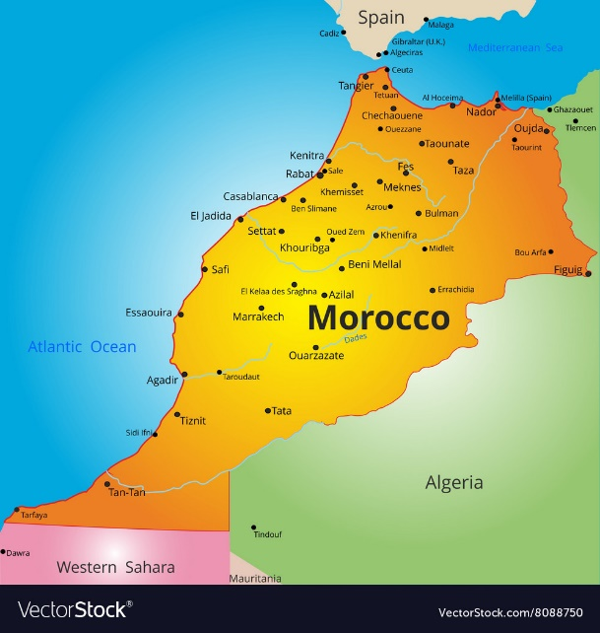
RESERVE MY SPOT!
Upon review of this itinerary, pricing, and terms for this trip, I would like to reserve ___ spot(s) on this trip by making a non-refundable deposit of $450 per person. I understand and agree to make payments according to the payment plan. Checks, credit cards*, Venmo (@Laurie-Scott-43) are accepted.
To start your reservation, please complete and return this form to Wide Horizons Travel at laurie@widehorizonstravel.com. Upon receipt of this form, Wide Horizons Travel will be in contact to collect the required information and deposit.

Name(s): _________________________________________________________________________________________
Preferred Email: _____________________________________________ Preferred Phone: ______________________
Signature ________________________________________________________________________date: ____________
CANCELLATION POLICY:
Deposit of $450 is non-refundable.

*Save $132 pp on credit card fees and pay by check. Pay in full by March 1, 2024, and save $250 per person.

Final payment is due by September 1, 2024, unless paid in advance per above.

If you cancel your reservation before September 1, 2024, there is a 25% cancellation penalty.
There is a 50% penalty if you cancel your reservation between September 1 and October 15, 2024.
There is a 75% penalty if you cancel your reservation between October 15 and December 14, 2024.

No refund is available after December 14, 2024. For these reasons, travel insurance is strongly recommended.

Wide Horizons Travel, 45 Sunset Road, Bay Shore, NY 11706 * 860-510-6740 * www.widehorizonstravel.com

